Table of Contents
Open edX Named Releases 2
What changes will you see in the Open edX changes in Hawthorn? 2
Improved discussion forum features 5
Override learner scores for individual problems 6
Instructor dashboard – new ORA report (this is not the Raccoon Gang custom report) 7
Resume Button 7
Interpreting the different "View As" options in Open edX 7
Interpreting the different View As options in the LMS 9
Staff View 9
Learner View 10

Open edX Named Releases

edX created “Open edX named releases”, which are distinct from the daily deployments to edx.org and have a longer release cycle (on the order of six months between each release). These releases will be tested both by edX and by the Open edX community.
Open edX releases are named alphabetically with botanical tree names. Ironworks has been released and Juniper is in the works. It can take the vendors 6 months or more to upgrade to the next version due to all of the customizations.

What changes will you see in the Open edX Hawthorn?

First and foremost what you will notice is that the Open edX HOME tab has been removed and the content moved to the Course tab. Don’t fear, the Greeting page content moved to the Course tab!
StartLearning.uw.edu old version of Open edX Home webpage

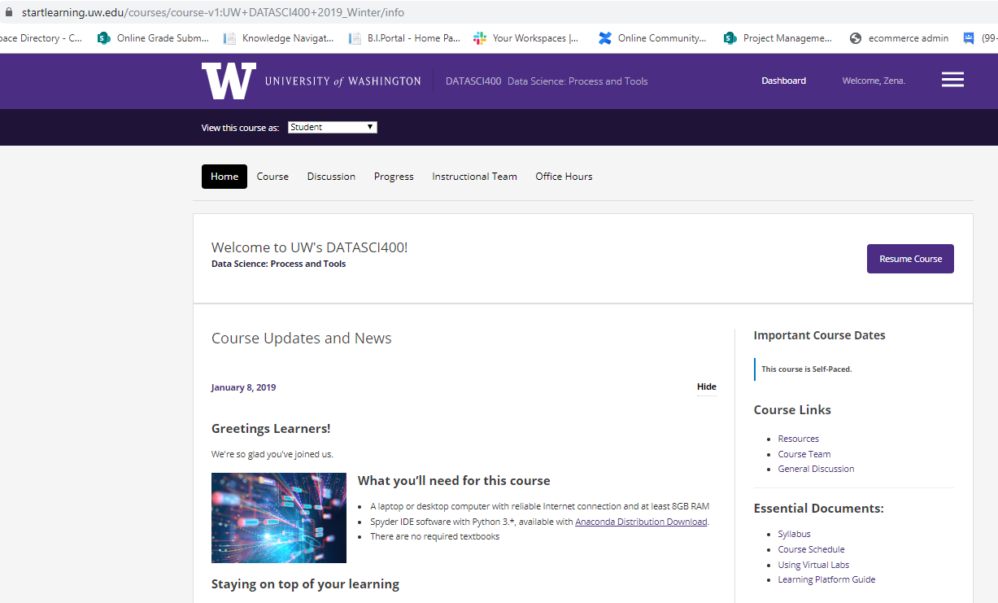

Startlearning.uw.edu New Course webpage in Hawthorn (minus the Home tab) it’s really not that much different, it’s more streamlined.

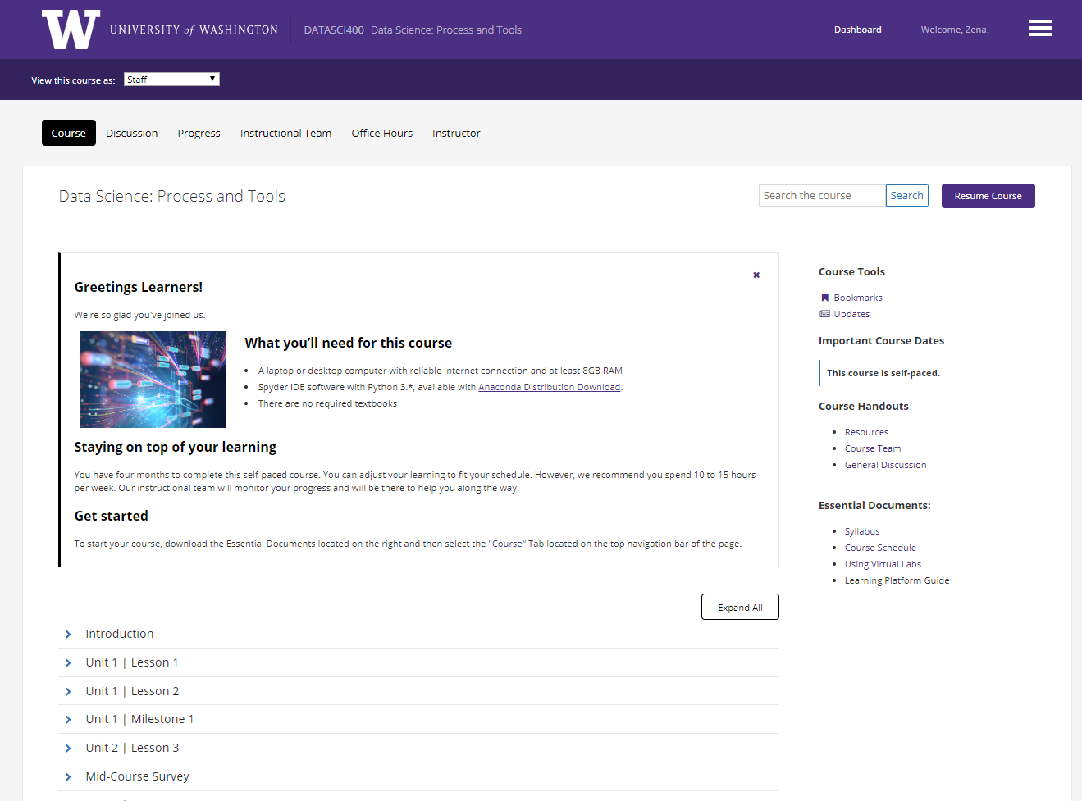

Note: To hide the Greetings page content and view only the course outline click on the ‘X’. This is very similar to the ‘hide’ option in the current version.
Switching between the Greetings content page and the course outline page is easy. Just click on the Updates menu in Course Tools. Why is the menu for the Greetings page is titled ‘Updates’? Good Question. We have a request to have this changed to a word that is related to the ‘greetings page’ after we launch Hawthorn.
This is the Greetings page in Hawthorn minus the course outline.
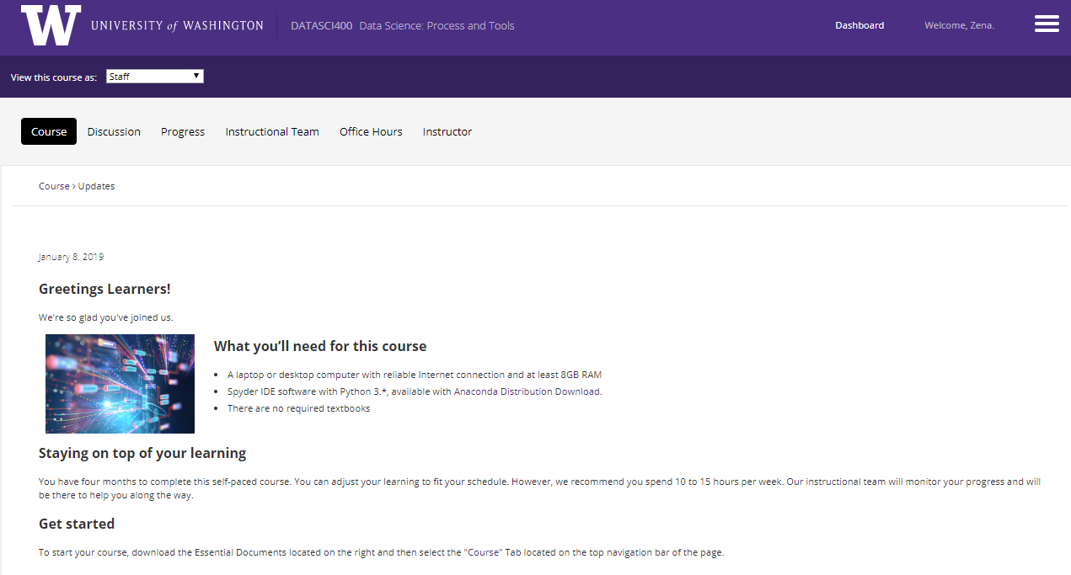
NOTE: Post launch of Hawthorn Appsembler will look into changing the text ‘Updates’, which displays the Greeting page, to a word that is more user friendly.

Improved discussion forum features

Inline discussions now expand by default. This change has resulted in a 3x increase in participation in the discussion forums. The first time a learner’s post receives a comment, they will receive an email message which contains the comment and a link back to the course discussion post.

After a learner or course team member creates a post in the course discussions, the platform sends the following email message the first time a learner or course team member replies to the original post.

The message also contains a View discussion option that takes the learner to the discussion post. The platform does not send individual messages for any additional replies on the post. However, the learner automatically receives a daily digest email message that summarizes additional activity on the post.

Override learner scores for individual problems

Course teams now have the ability to override learner scores for individual problems. This can be done through a setting on both the Instructor Dashboard and the Staff Debug viewer.

Override learner scores via the Instructor dashboard
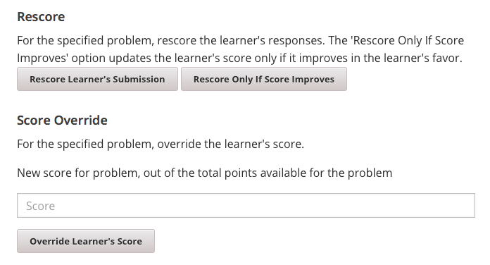
Override learner scores via the Staff Debug view
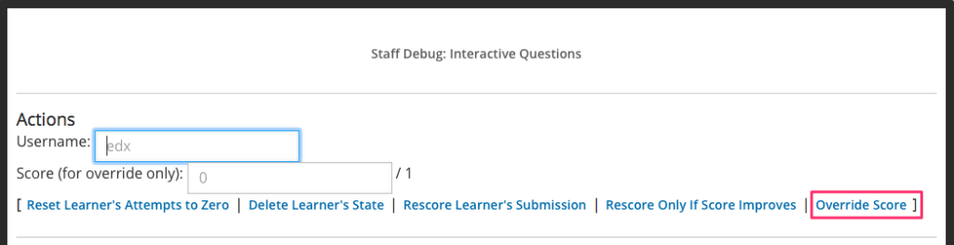

Instructor dashboard – new ORA report (this is not the Raccoon Gang custom report)
Currently Appsembler is working on a bug in the ORA report. This means that the ORA report may not be fully functional by go live. The ORA dashboard allows instructors to view Statistics for all ORA Assignments in their course.
To view metrics about all of the ORA assignments in a course, follow these steps.
- View the live version of the course.
- Select Instructor to open the instructor dashboard.
- On the instructor dashboard, select Open Responses.
The Open Responses tab of the instructor dashboard displays the following information.
- The number of course units that include an ORA assignment.
- The number of ORA assignments in the course.
- The total number of submitted responses.
- The number of learners who are in each of the training, peer, self, and staff workflow states.
- The number of learners who have received a final grade.
The Open Responses tab also displays the same information for each separate ORA assignment in the course, grouped by the course units that include ORA assignments.

Resume Button
Another nice bonus is the updated Resume Course button. Often, learners love to jump ahead and get a sneak peek at upcoming course content, but they might have trouble finding their way back to where they were working. With Hawthorn, the Resume Course button on the Course page returns the learner to the last unit they completed, instead of the last unit they visited.

Interpreting the different "View As" options in Open edX
As a course staff member, there are several ways to view your course the LMS (Learning Management System). Here's how to toggle between them and what each option means.

Changing view in the LMS
Changing how you're viewing a course in the LMS is easy to do.
- In the top left part of the screen, locate the drop down menu that reads View this course as:
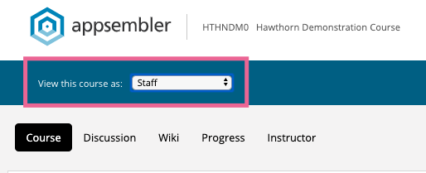
- From this drop down menu you can select a number of different options. Simply choose one and release. The page will automatically refresh in the selected view.
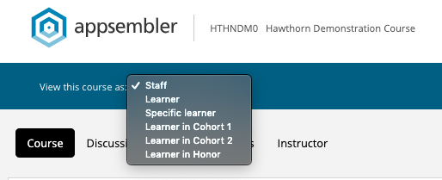
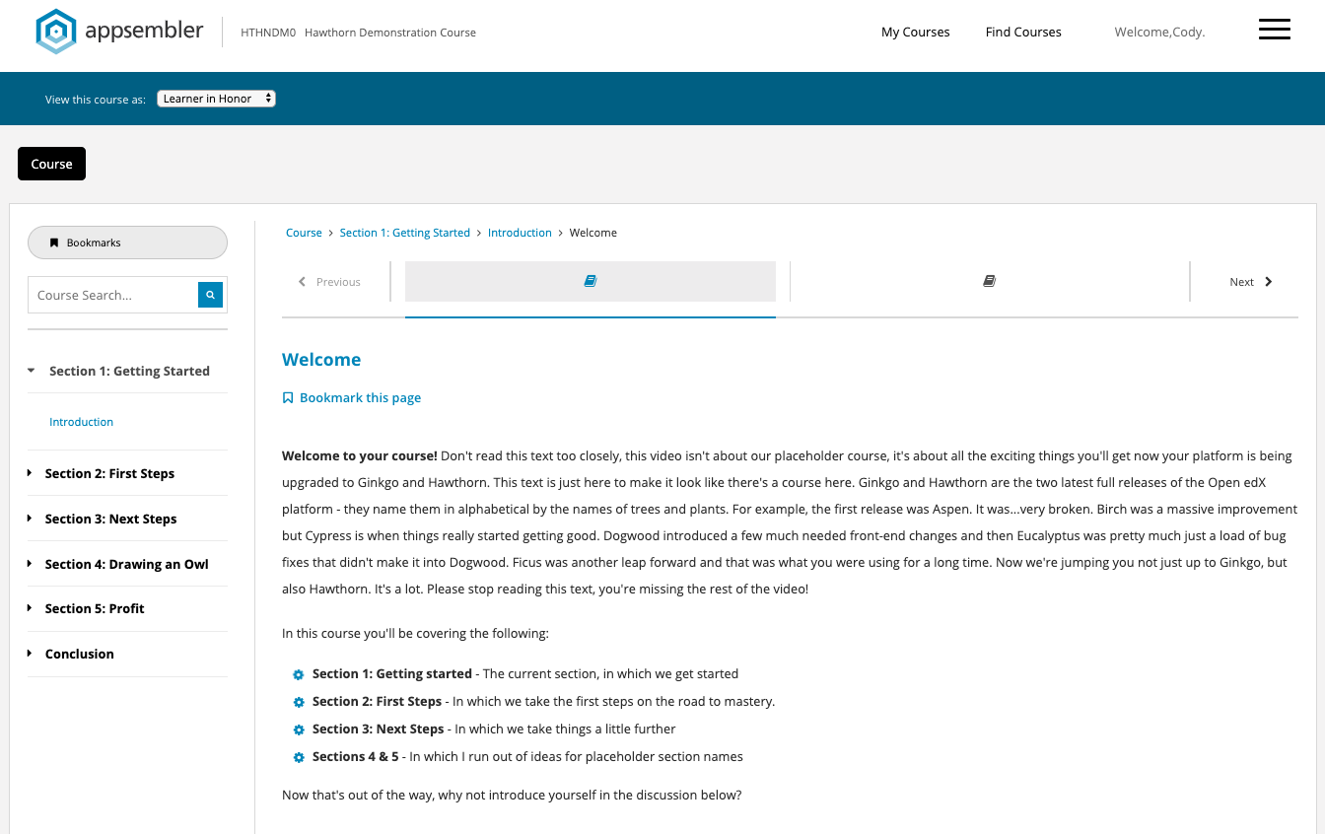
NOTE: If you don't see the View this course as drop down menu, it is likely because your Course Start Date has not yet been reached. The drop down will only appear for courses that have officially begun. If you would like to use this feature anyway, simply set your course start date to the past. You can always change it back later!

Interpreting the different View As options in the LMS
There are several different ways in which to view your course in the LMS. Here's what each one entails.

Staff View
Viewing a course as Staff is the default. This view will show you everything in your course. Some specific points of interest that are only available to Staff include:
- View Course in Studio buttons - These allow you to jump directly into that particular unit in Studio from the LMS
- Staff Debug Info - A panel to help you manage several technical aspects of a particular component
- Instructor Dashboard - The Instructor Dashboard is where you do all of the managing of your course and the learners enrolled in it.
- Staff-Only sections of the course - Any area you've denoted as Staff only in Studio will only be visible in the LMS using the Staff LMS view option.
- Content from all cohorts - If your course has cohort-specific content, viewing the LMS as Staff will allow you to see your page with all content, regardless of cohort visibility. In the screenshot below, notice the "Instructions for Windows" and "Instructions for MacOS" which are designed to be only visible to their respective cohorts
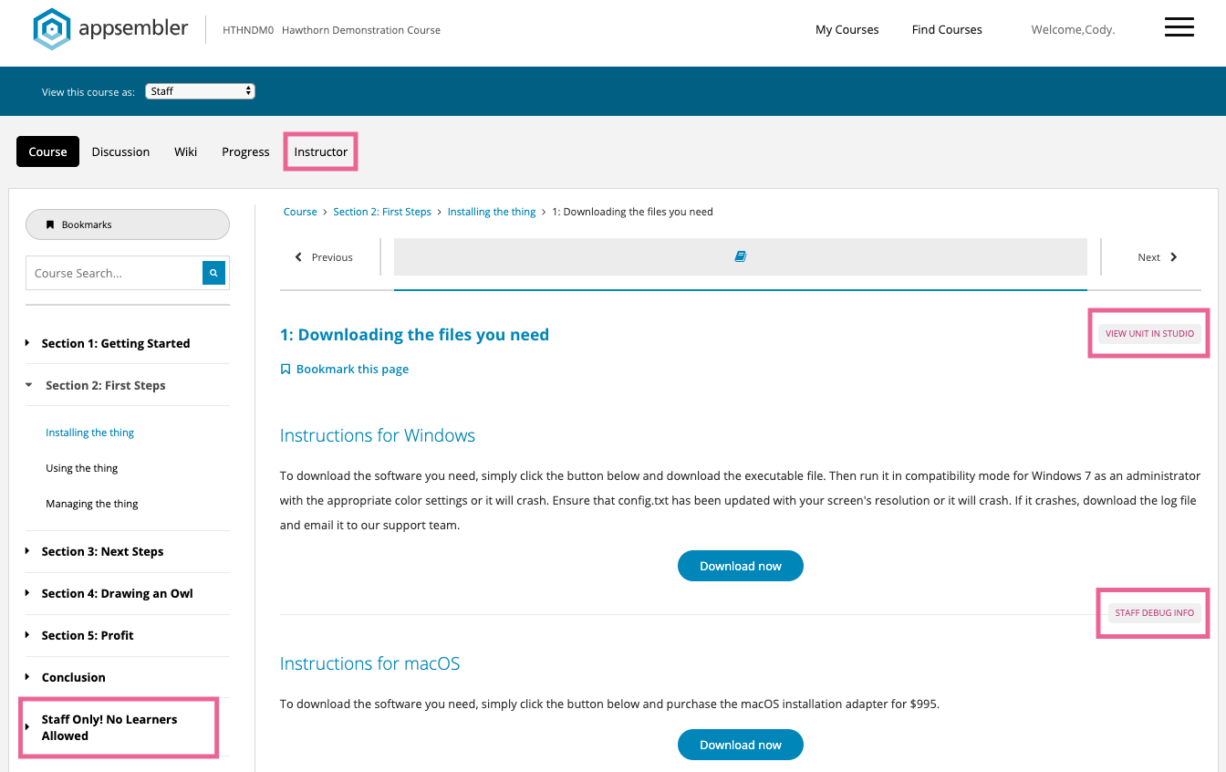
The only pieces of content that are not visible in the LMS - even to staff users - are Draft content. This is content that has not been published from Studio yet.

Learner View
The learner view is what your course looks like to a generic learner (a.k.a. student) in your course. In this view, essentially all of the additional items you see as a Staff viewer go away. All you're able to see is the content that is available to learners in your course.
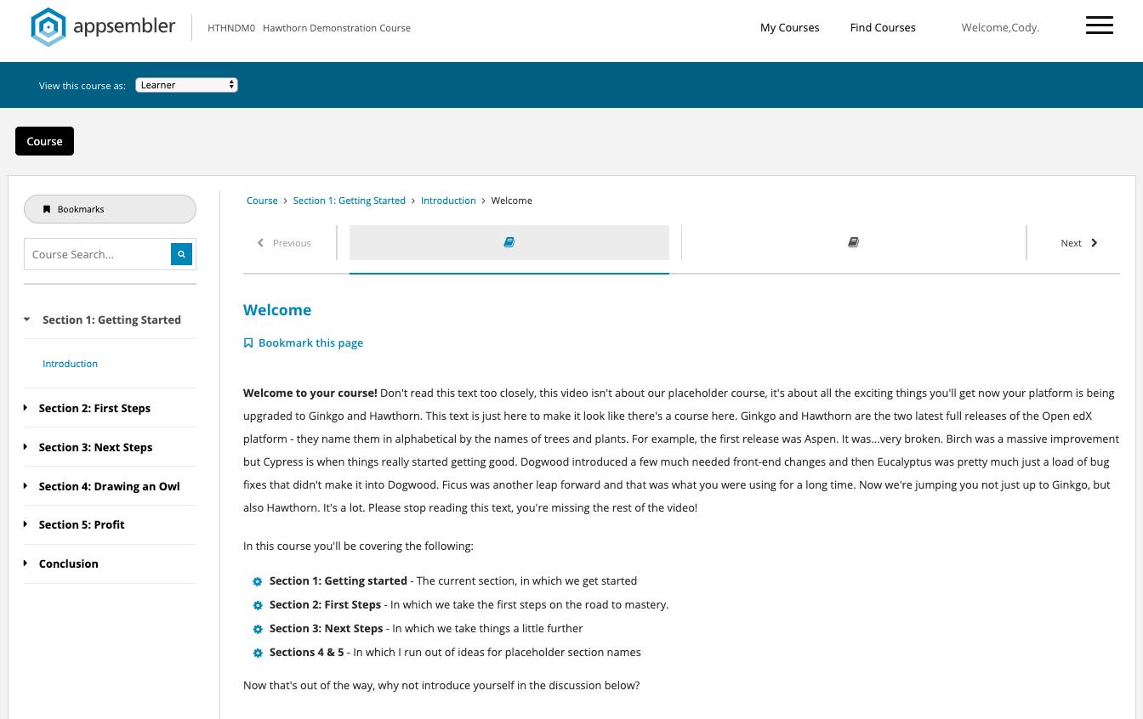
In the generic Learner view, you will be unable to see Discussion forums or Progress pages since those are tied to specific learner interactions within the course.

Specific Learner
By selecting Specific learner, you will be able to type in an enrolled learner's username or email address in order to view the course as if you were that learner. By viewing a course as a specific learner, you'll be able to see how that learner has answered specific problems in the course, what discussions they have participated in, and their individual progress page. If the learner is in a cohort, you will also be able to see what cohort-specific content or discussions that learner has available to them.
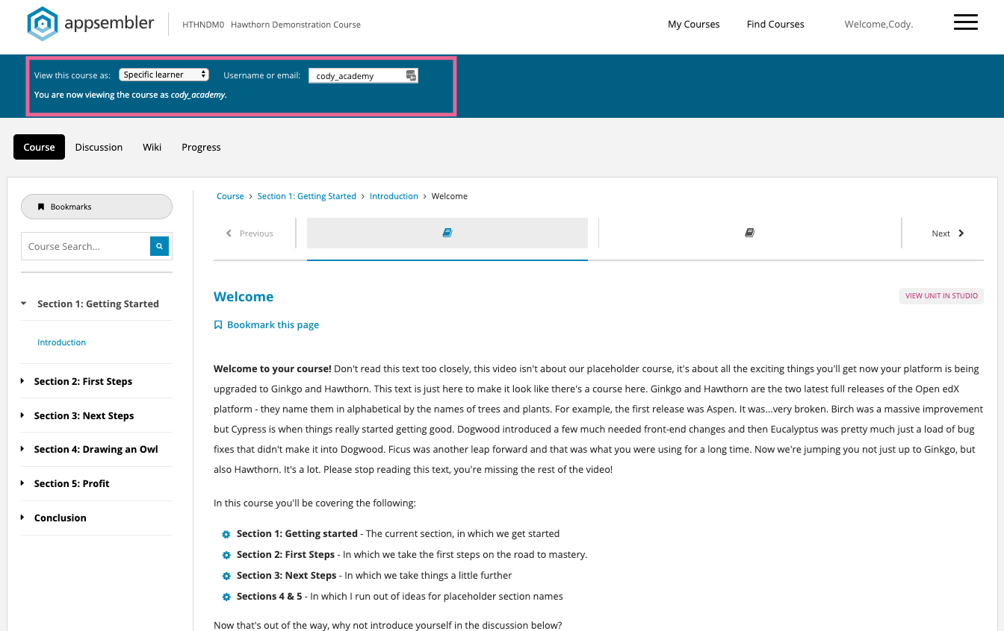
If your course includes any graded content, you can click on the Progress page to see that learners grades throughout the course.
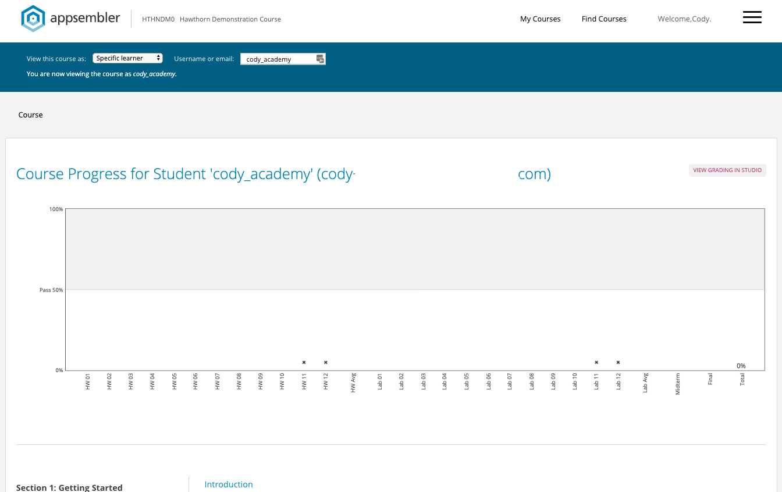

Learner in [Cohort Name]
Using the Learner in [Cohort Name] view allows you to see the course as a generic member of a specific cohort. This means you will be able to see specific pieces of content and/or discussions that are only visible to members of that cohort. Everything else about this view mode is the same as the generic Learner view mode.
Example – Cohort 1
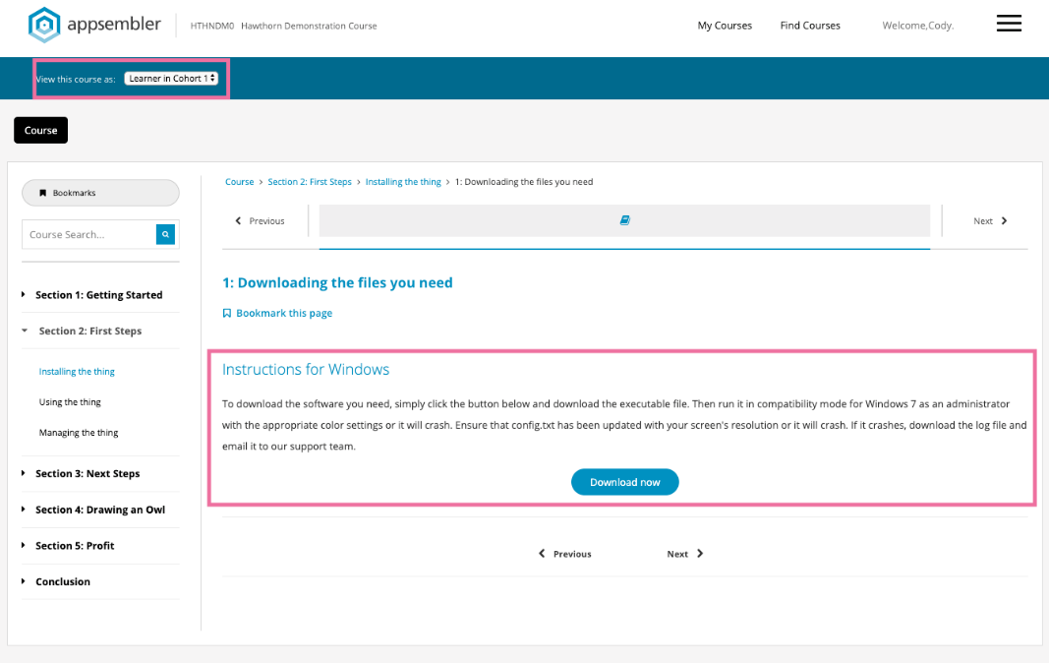1
Example - Cohort 2
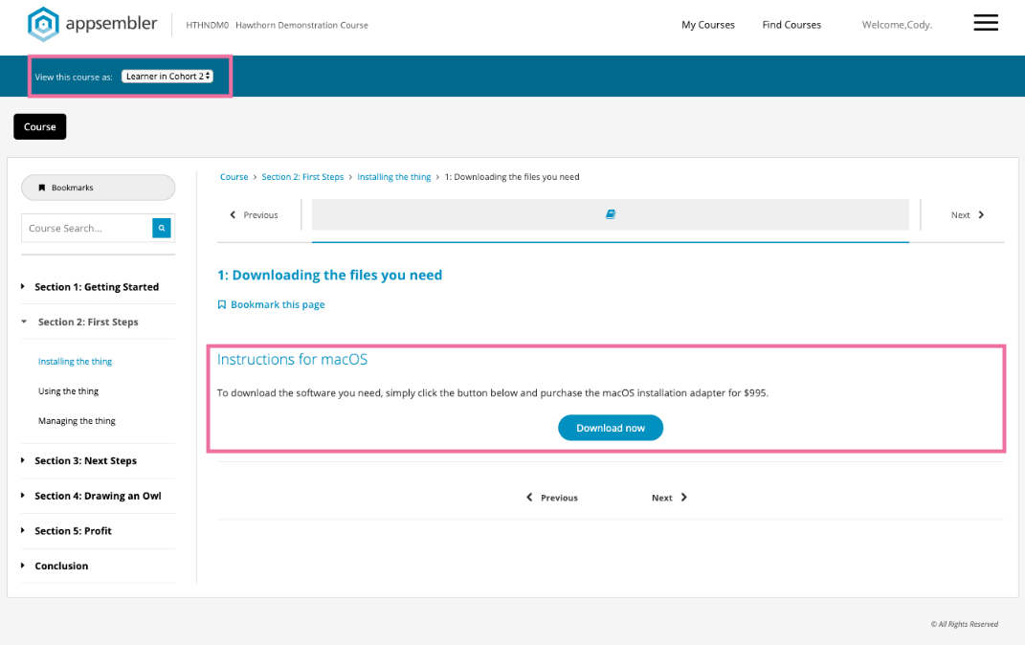

Learner in Honor
Some Open edX sites use what are called "enrollment tracks" which, to oversimplify things, allow learners to have a different course experience based on what their learning goals are (eg. to audit the course, to earn a professional certificate, etc). In nearly all Appsembler-hosted Open edX sites, only a single enrollment track is available, and that is the honor track. This has to do with making HTML certificates available to organizations that wish to utilize them. Because honor is the only available enrollment track, this view mode is the exact same as the Learner view Mode
.

The Following information along with a newly revised ‘what is new in Hawthorn’ will be emailed to active students along with information about when the system will not be available.
We will update the Student StartLearning Learner Guide in the production system within hours of launching Hawthorn.
Changes in Hawthorn for existing students
The HOME tab has been removed and the content moved to the Course tab
Screen shot of the startlearning.uw.edu before the upgrade
New main Course webpage in Hawthorn minus the Home tab
Note: To hide the Greetings Learner content and view only the course outline click on the ‘X’. This is very similar to the ‘hide’ option in the current version.
Changes in Startlearning.uw.edu
- Another nice bonus is the updated Resume Course button. Often, learners love to jump ahead and get a sneak peek at upcoming course content, but they might have trouble finding their way back to where they were working. With Hawthorn, the Resume Course button on the Course page now returns the learner to the last unit they completed, instead of the last unit they visited.

- The green progress check marks are new and provide a visual aid and do not have any bearing on the student course completion status or certificate eligibility.
Students can see their grading and progress towards the passing score in their course on the progress tab.
  - To receive a checkmark, you must complete all of the following actions.
    - View all of each video in the unit.
    - Problems in the unit.
    - View all HTML content in the unit for at least five seconds.

When you are working in a course, green check marks are visible in two places.
- The course outline on the Course page.
- The navigation bar at the top of each page in the course.
For example, in the following image, the learner has completed all of the content in the “Introduction” part of the course. The learner has also completed some of the content in the “Module 1: Experiencing Course Content” part.
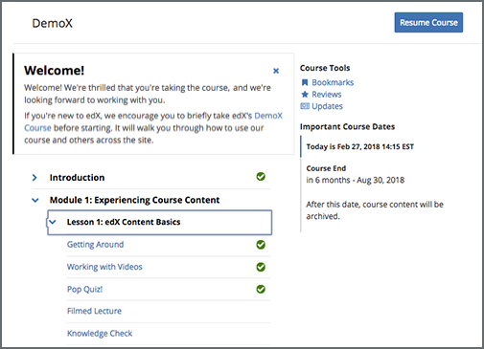
In the following image, the learner has completed the first three units in the “Lesson 1: edX Content Basics” lesson.
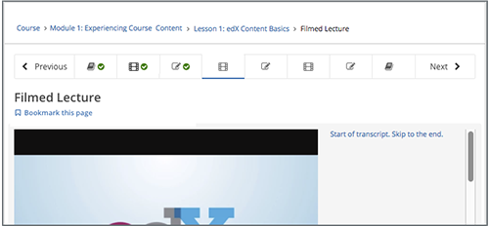
(For some advanced assignment types a check mark may not appear. This does not impact the student course grading.)​

Improved discussion forum features
Inline discussions now expand by default. This change has resulted in a 3x increase in participation in the discussion forums on edX.org. The first time a learner’s post receives a comment, they will receive an email message which contains the comment and a link back to the course discussion post.

After a learner or course team member creates a post in the course discussions, the platform sends the following email message the first time a learner or course team member replies to the original post.

The message also contains a View discussion option that takes the learner to the discussion post.

The platform does not send individual messages for any additional replies on the post. However, the learner automatically receives a daily digest email message that summarizes additional activity on the post.

